## Selenium/WebDriver Framework

### Configuration Instructions

**Notes**:

* I may be going into more detail here than you need, but please bear with me. It took me a while to get it to work, so I trust these steps. (Indeed, parts of my configuration may seem illogical, but I have not felt like changing it, lest I break something!)
* The order of execution of the IE and ant bullets doesn't matter, but I recommend following the rest of the bullets in the order given.

**Caveat**: my machine is running the 64-bit version of Windows 7 Enterprise. If your configuration differs from that, some of the following steps may require tweaking.

**Request**: please do not modify any framework code at this time

**My** **apologies** if you are familiar enough with the tools below that you find my level of detail annoying. I am trying to be thorough, and also make this document accessible to a wide audience

* **Internet Explorer**
  + Use IE9, 32-but version (illogical given my 64-bit OS)
    - note that I tried IE8, but it did not work)
  + For WebDriver to work, the zoom level must be set to 100%
  + For WebDriver to work, the protected mode settings must be the same for all zones. In other words, in Internet Options->Security, the "Enable Protected Mode" check box must have the same setting (checked or cleared) for all four zones. The setting does not matter – the key point is that the setting must be the same for all zones.
* **Java**
  + jdk1.7.0_02 (64-bit)
  + jre7
  + I have both installed in the 64-bit version of Program Files (not "Program Files (x86)")
  + create the environment variable JAVA_HOME=C:\Program Files\Java\jdk1.7.0_02
  + add C:\Program Files\Java\jdk1.7.0_02\bin to your PATH environment variable
  + do NOT create a CLASSPATH environment variable; if you have one, rename it or delete it
  + note that when you run a test in Eclipse, you may encounter an error message having something to with an IBM component. Brijesh and I ran into that, and found that it was caused by QC's Java setup. I don't remember the details, but I believe the way around the problem is to search your machine for other instances of Java (I believe there is one in the c:\Windows directory tree) and delete them all. Then configure QC to use your new Java configuration.
  + my setup:

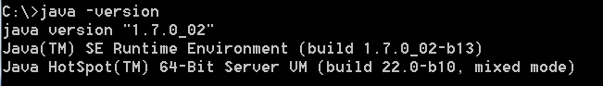

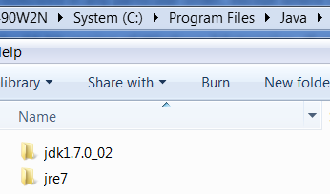

* **Ant**
  + ant 1.8.2 (http://apache.mirrors.lucidnetworks.net//ant/binaries/apache-ant-1.8.2-bin.zip)
  + I have it installed in the 64-bit version of Program Files (not "Program Files (x86)")
  + create the environment variable ANT_HOME= C:\Program Files\Ant\apache-ant-1.8.2
  + add C:\Program Files\Ant\apache-ant-1.8.2\bin to your PATH environment variable
  + my setup:



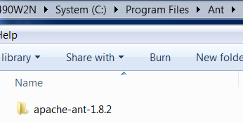

* **JUnit**
  + download junit.4.10.zip from <https://github.com/KentBeck/junit/downloads>
  + put the jar wherever you wish; I put mine at c:\JUnit
  + create the environment variable JUNIT_HOME= C:\JUnit
* **Selenium/WebDriver**
  + download selenium-server-standalone-2.19.0.jar from <http://selenium.googlecode.com/files/selenium-server-standalone-2.19.0.jar>
    - note that I am using 2.17, but feel free to go ahead with 2.19
  + download selenium-java-2.19.0.zip from <http://selenium.googlecode.com/files/selenium-java-2.19.0.zip>
    - note that I am using 2.18, but feel free to go ahead with 2.19
    - the only thing you care about in this .zip is the selenium-java-2.19.0.jar file
* **Eclipse**
  + Eclipse IDE for Java Developers, 32-bit version (<http://www.eclipse.org/downloads/download.php?file=/technology/epp/downloads/release/indigo/SR2/eclipse-jee-indigo-SR2-win32.zip>)
    - I do not believe I installed any additional plug-ins
  + I have it installed in the 32-bit version of Program Files ("Program Files (x86)")
  + create an Eclipse workspace, wherever you wish. I used my user directory: C:\Users\blazej
  + create a new Java Project named "EISTestAutomation"
    - The location should be the default, i.e., the location of your workspace (in my case it is C:\Users\blazej
    - click the “Use a project specific JRE” radio button, then click the “Configure JREs” link, choose Add, then “Standard VM”, and then populate the “JRE home” box by navigating to the same directory as your JAVA_HOME setting. Click Finish. In the next dialog, check the box next to the entry you just created. (Optionally, delete the other one by highlighting it and clicking Remove.) You should end up with something like this:

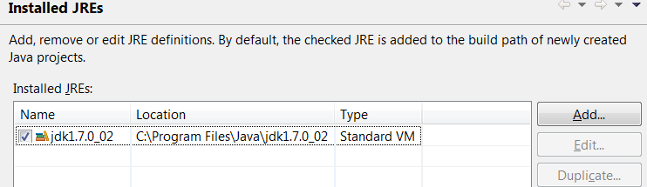

* + - click OK, and accept defaults for the rest of the fields in the New Java Project dialog
  + create an environment variable that references the location of the Eclipse project, for example: EIS_TEST_AUTO_HOME=C:\Users\blazej\EISTestAutomation
  + move the two Selenium/WebDriver jars (see previous major bullet) to your Eclipse project's lib directory (if there isn’t a lib directory, create it)
  + in Eclipse, add JARs
    - in Project->Properties->Java Build Path->Libraries, choose Add JARs, navigate to the lib directory, highlight the two jars, and click OK
    - in Project->Properties->Java Build Path->Libraries, choose Add External JARs, navigate to your JUnit jar, and add it
    - your setup should now look like this:

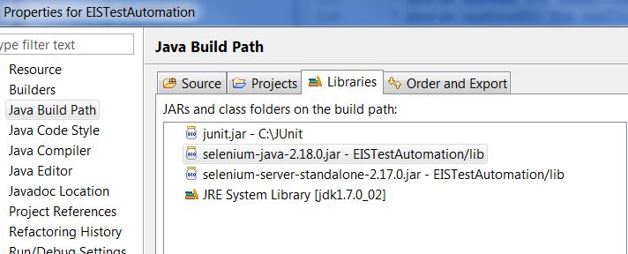

* + - your Eclipse .classpath file (located at C:\Users\blazej\EISTestAutomation) should look like this:

<?xml version="1.0" encoding="UTF-8"?>

<classpath>

<classpathentry excluding="**/doc/*|**/resource/*|**/testdata/*" kind="src" path="src"/>

<classpathentry kind="con" path="org.eclipse.jdt.launching.JRE_CONTAINER/org.eclipse.jdt.internal.debug.ui.launcher.StandardVMType/jdk1.7.0_02"/>

<classpathentry kind="lib" path="lib/selenium-server-standalone-2.17.0.jar"/>

<classpathentry kind="lib" path="C:/JUnit/junit.jar"/>

<classpathentry kind="output" path="bin"/>

</classpath>

* + edit your Perforce workspace (see next major bullet), and then synch (note that you may need to do a “force” synch); after doing so, your Eclipse Package Explorer view should look like this (except you won't have the archive folder, and your jar versions will be different):

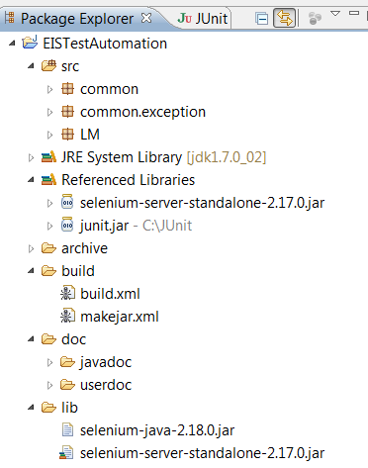

* **Perforce**
  + add these lines to your workspace, and modify them to match the location of your Eclipse workspace and the name of the Perforce workspace

//it/QAAutomation/Selenium/EISTestAutomation/src/... //[Perforce workspace name]/Users/blazej/EISTestAutomation/src/...

//it/QAAutomation/Selenium/EISTestAutomation/lib/... //[Perforce workspace name]/Users/blazej/EISTestAutomation/lib/...

//it/QAAutomation/Selenium/EISTestAutomation/build/... //[Perforce workspace name]/Users/blazej/EISTestAutomation/build/...

//it/QAAutomation/Selenium/EISTestAutomation/doc/... //[Perforce workspace name]/Users/blazej/EISTestAutomation/doc/...

* **To follow**
  + running a test using ant
  + troubleshooting (based largely on feedback from offshore team)